* 1) Generate a signal 500Hz with 40% duty cycle
* **CALCULATIONS:**
* As we have given frequency =**500Hz**
* We know that Time period **(T)=1/f**
* **T=1/500=0.002** or **2ms**
* Now we know that duty cycle=uptime/total time
* Duty cycle=**40% or 0.4**
* **0.4=uptime/0.002**
* Uptime=**0.0008 or 800micros**
* **As total time =2ms so the we have uptime of 800micrs and then 1200mics**

#include <reg51.h>

#include <stdio.h>

sbit MYBIT=P1^2;

void start_timer( );

void timer0() interrupt 1

{

if(MYBIT)

{

//delay of 1200 micro second or 1.2ms

TH0=0xFC;

TL0=0xDF;

}

else

{

//delay of 800 microsecond

TH0=0xFB;

TL0=0x4F;

}

MYBIT = ~MYBIT;

}

void init()

{

TR0=1;

}

void main(void)

{

init();

start_timer();

while(1)

{

}

}

void start_timer()

{

TMOD = 0x01;

IE=0x82;

}

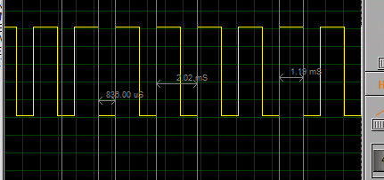

* 2) Generate a signal of 600Hz with 60% duty cycle on P1.3

Hint: use timer

* **CALCULATIONS:**
* As we have given frequency =**600Hz**
* We know that Time period **(T)=1/f**
* **T=1/600=0.001** or **1ms**
* Now we know that duty cycle=uptime/total time
* Duty cycle=**60% or 0.6**
* **0.6=uptime/0.001**
* Uptime=**0.006 or 600micros**
* **As total time =1ms so the we have uptime of 600micrs and then 400mics**

#include <reg51.h>

#include <stdio.h>

sbit MYBIT=P1^2;

void start_timer( );

void timer0() interrupt 1

{

if(MYBIT)

{

//delay of 600 micro second or 1.2ms

TH0=0xFd;

TL0=0xA7;

}

else

{

//delay of 400 microsecond

TH0=0xFE;

TL0=0x6F;

}

MYBIT = ~MYBIT;

}

void init()

{

TR0=1;

}

void main(void)

{

init();

start_timer();

while(1)

{

}

}

void start_timer()

{

TMOD = 0x01;

IE=0x82;

}

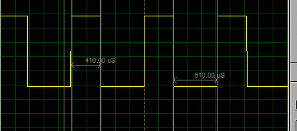

3) Generate a signal of 100Hz with 40% duty cycle on P1.2 When a user presses a button at P2.3 the signal change to 300Hz with 40% duty cycle.

* **CALCULATIONS:**
* **A**
* As we have given frequency =**100Hz**
* We know that Time period **(T)=1/f**
* **T=1/100=0.01** or **10ms**
* Now we know that duty cycle=uptime/total time
* Duty cycle=**40% or 0.4**
* **0.4=uptime/0.01**
* Uptime=**0.004 or 4ms**
* **As total time =10ms so the we have uptime of 6ms and then 4ms**
* **B**
* As we have given frequency =**300Hz**
* We know that Time period **(T)=1/f**
* **T=1/300=0.003** or **3ms**
* Now we know that duty cycle=uptime/total time
* Duty cycle=**40% or 0.4**
* **0.4=uptime/0.03**
* Uptime=**0.0012 or 1.2ms**
* **As total time =3ms so the we have uptime of 1.2ms and downtime time of 1.8ms**

#include <reg51.h>

#include <stdio.h>

sbit MYBIT=P1^2;

sbit PIN = P2^3;

void start_timer( );

void timer0() interrupt 1

{

if(PIN)

{

if(MYBIT)

{

//delay of 6ms

TH0=0xE8;

TL0=0x8F;

}

else

{

//delay of ms

TH0=0xF0;

TL0=0x5F;

}

MYBIT = ~MYBIT;

}

else

{

if(MYBIT)

{

//delay of 1.2ms

TH0=0xFB;

TL0=0x4F;

}

else

{

//delay of 1.8ms

TH0=0xF8;

TL0=0xF7;

}

MYBIT = ~MYBIT;

}

}

void init()

{

TR0=1;

}

void main(void)

{

init();

start_timer();

while(1)

{

}

}

void start_timer()

{

TMOD = 0x01;

IE=0x82;

}

